COVID-19 Risk assessment / Broomy Hill / method or task statement for:

Name of Coaches: All Hinton FC registered team coaches, Junior and Adult teams

This document details what can cause harm, the significant risks involved and what methods should be in place to keep our people safe and well.
Description of the process / task / equipment
Organised, competitive football matches, coaching with fitness and ball work. Equipment will include balls, cones, poles, bibs, running ladders, pop up and fixed goal posts and nets. The use of changing facilities may be occasionally permitted.

What could cause harm or ill-health? – What are the hazards?
Access to Site |  | Electricity | ☐ | Lighting levels | ☐ | Vehicles / mobile plant | ☐
Animals | ☐ | Enclosed / confined space |  | Lone working | ☐ | Vermin / disease | ☐
Asbestos | ☐ | Equipment |  | Manual handling | ☐ | Violence | ☐
Bacteria/virus |  | Ergonomics eg kneeling |  | Restricted access |  | Water | ☐
Body fluids |  | Excavations | ☐ | Sharps | ☐ | Weather(wind/rain/ice)
Burns / scalds | ☐ | Fire / Explosion / Hot work | ☐ | Slips, trips, falls |  | Wet surfaces
Debris |  | Hand / Power tools | ☐ | Sun / UV light |  | Work around people | ☐
Dust / fumes / vapours / gas | ☐ | Hazardous substance / waste | ☐ | Temperature extremes
Anything else?
Not currently known at this time of completing the Risk Assessment
Frequency and duration of Activity - How long is it likely to take and how often are we going to do it?
Competitive matches will have a duration of a maximum 90 mins
Coaching sessions will have duration of a maximum 90 mins and weekly for each team

Potential harm & residual risk evaluation – risk is the likelihood of harm happening and is calculated by multiplying ‘Likelihood’ and ‘Severity’
Likelihood
5 – Occurs repeatedly/event only to be expected
4 – Not surprising when happens / will occur
3 – Could occur sometimes
2 – Unlikely, though conceivable
1 – So unlikely, probability close to zero

Severity
5 – Death
4 – Long injury / loss of limb etc
3 – Results in 3+ days sickness/injury
2 – Injury requiring medical treatment
1 – No medical treatment required

Likelihood | 5 | 5 | 10 |  | 15 | 20 |  | 25
 | 4 | 4 | 8 |  | 12 | 16 |  | 20
 | 3 | 3 | 6 |  | 9 | 12 |  | 15
 | 2 | 2 | 4 |  | 6 | 8 |  | 10
 | 1 | 1 | 2 |  | 3 | 4 |  | 5
 | 0 | 1 | 2 |  | 3 | 4 |  | 5
 |  | Severity
 |  | Low |  | Medium |  |  | High

Potential harm – what could happen? Or why you believe it couldn’t | L | S | Risk rating
Cross contamination by participants in the session or attending to view the coaching | 3 | 3 | 9
The social distances and requirement of the coaching session with hygiene are not adhered to by the players or spectators | 3 | 3 | 9
Contact with the equipment is known and hygiene procedures are not correctly completed after use | 3 | 3 | 9
Equipment not disinfected after use with approved chemicals | 3 | 3 | 9
Cross contamination during use of toilets, changing facilities and showers and drying rooms | 2 | 3 | 6
Facilities and showers not cleaned properly after use using appropriate disinfectant. | 2 | 3 | 6
Close contact due to over capacity and or ingress or egress issues into changing / shower facilities | 3 | 3 | 9
Any Activity which indicates a HIGH-Risk Outcome MUST be avoided

Controls in place / Coaching methods / procedures – thinking about Safe People, Safe Equipment, Safe Place

PROCEDURES AND ACTIONS REQUIRED

Please be mindful that all Coaches are volunteers and NOT experts in the Safety & Health care for the existing COVID-19 situation.

If the Coaches, Players and Parents are uncomfortable with any item with regards to the proposed controls included in this Risk Assessment, IMMEDIATELTY STOP the session and seek additional support the item

The Health and Safety of all the Hinton FC members and connected family and friends are the highest priority of the Hinton FC committee, please do not adopt unnecessary risks

The FA Covid 19 Safe Guarding Risk Assessment - This document is the KEY reference document to be read by all coaches LINK HERE

Attendance ratios Coach 1:29 players

Visiting teams - All visiting teams MUST have received the HINTON FC COVID-19 Risk Assessment a minimum of 24 hours prior to arriving at the Hinton FC arranged fixture and must complete a player attendance register prior to arrival at Broomy Hill. This register will be used to manage players in and out of the ground.

Welcoming Visitors to a Hinton FC fixture - A designated person is to welcome all visiting players and officials to the venue, ensuring that all safety requirements have been confirmed as being understood by the visitors. The following questions will be asked:

- Have you or anyone that you live with displayed any symptoms (continuous cough, high temperature, loss of taste or smell) of, or tested positive for Covid-19 in the last 14 days?
- Are you awaiting the results of a Covid-19 test?
- Do you live with someone who is shielding due to a specific health risk?

Player Briefing - Prior to commencing any football activity, all players, officials and visitors must confirm that they are not aware that they have any Covid-19 symptoms currently (as per the player welcoming brief detailed above). Any Players, officials or visitors exhibiting any Covid-19 symptoms will be asked to leave Broomy hill immediately and seek medical attention.

Player briefing of safe requirements - At the start of each session, coaches are to brief all players of the safety Hygiene requirements, including all players that arrive late and miss the original brief.

Parent briefing of safe requirements - Coaches to communicate to all parents prior to any session, that they MUST stay with their child or children for the duration of that session.

Session location rotation - When more than one group is training, there must be organise rotation of the groups so they don’t cross over the group when moving to the next coaching area.

Distance between teams - When more than one team is coaching at the same time, please provide a minimum of 10 Metres between the nearest potential contact points.

Drink bottles - All players MUST bring their own personal drinks bottle, NO sharing of drinks bottles will be permitted.

All Footballs MUST be disinfected before and after use.

Equipment to have hygienic cleaning pre and post use - All equipment that has been used during coaching sessions and matches must be sprayed with the provided disinfectants available in the storage container. Please refill all bottles when they are empty and dispose of all wipes in the Green Wheelie bin at the site entrance gate.

Clubhouse - The use of the clubhouse and changing facilities is only permitted on a limited basis. The changing and shower facilities are only to be used if absolutely necessary.

All players and officials that are able to, should arrive at the ground in full kit.

A Maximum of 7 people are able to change inside at any given point in time. Changing facilities and showers MUST be disinfected regularly (all surfaces wiped down, including the shower heads, tiles, toilet seat, handles, taps and basin).

The showers can only be accessed by a maximum 2 people at any time and those people must follow the one-way, convoy system and guided walkways, placing bags and towels in allocated zones.

Players should change, shower and dress in approved areas only (as detailed in the below image):

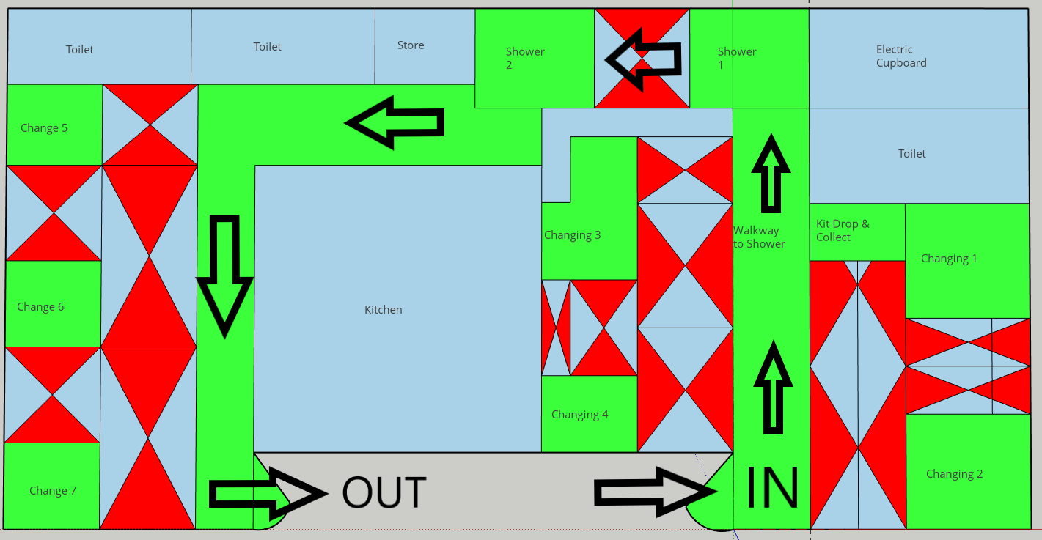

The home and away dressing room doors must remain open during changing and showering periods and the kitchen must not be in operation during this period.

Football boots should NOT be worn in the changing areas and players must be outside before putting their boots on.

Players should remove boots before they enter the changing facilities to change or shower and should NOT clean boots in the shower.

Once changed, players should store all of their clothing and bags in their car – there is no storage space for personal belongings in the clubhouse or changing rooms.

Disinfectant, Detergent and Wipes are available in the clubhouse, please highlight if stock levels are getting low.

A dip bath and disinfectant spray bottles are ready for use in the Equipment container.

Once all players and officials have left the ground, an appointed club official will disinfect the internal areas using a pressurised disinfectant spray and a cleaning record will be detailed.

Thank you for adhering to this Risk Assessment and procedures, by working together we can provide the confidence to all our members and observers that Hinton FC operate to the highest safety standards.

Keep Safe
Graham Andrews
Chairman
Tel 07974447622
Email Hintongraham@hotmail.co.uk

Assessment completed by: | Graham Andrews | Date of completion | 10/09/2020

