

HINTON FOOTBALL CLUB

**DO YOU KNOW YOUR CLUB OFFICIALS?**

**Chairman**

*Overall direction and day to day running of Hinton FC*

**Graham Andrews** 07974447622

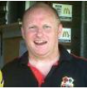

**Junior Welfare Officers**

*Match day and junior Welfare Supporting players and officials at Broomy Hill*

**Simon Hall** **07773364049 / Alan Preissler 07769 176759**

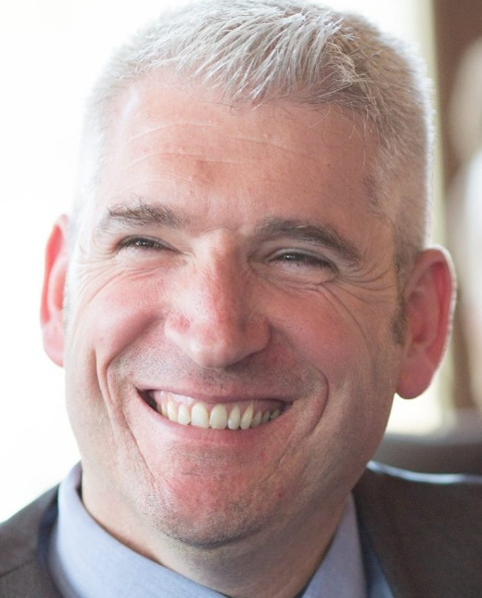

**Senior/Junior Secretary / Club Welfare Officer**

*Secretary to the Senior and Junior teams, assistant to Chairman and Club Welfare co-ordinator and policy writer.*

**Graham Goodfellow** **Tel** 07734004157



**Club Treasurer**

**Sam Birch** 07866829746

**Team Managers/Coaches**

**First Team: Mike Marsden, Darren Birch, Rod Haslam.**

**Reserve Team: Neil Marshall.**

**Veterans: Rod Haslam**

**U15: Wayne Teale, Paul Thomas.**

**U13: Darren Birch, Rod Haslam.**

**U11 Boys: Mike Andrews. Steve Gibbs, Simon Lissaman.**

**U8/U10/u12 Girls: Steve Gibbs.**

**Saturday Club: Steve Gibbs**

**CP Disability Football: Connor Lambert.**

**All club codes of conduct and contact numbers can be found at:**

[**http://www.hintonfc.co.uk/club-codes-of-conduct.php**](http://www.hintonfc.co.uk/club-codes-of-conduct.php)