Measage Board
.
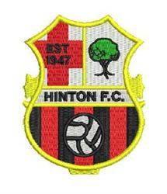

Training Wednesday
Hereford Academy
Astro
6.45pm – 8.00pm

Futsal Training Thursday
At The Point 4
7pm – 8pm

Match Reports
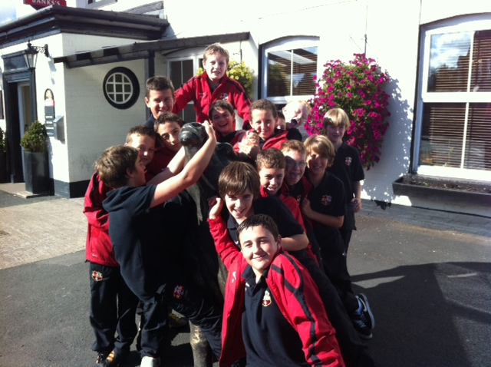

The boys having a little fun prior to the post match refreshments at the The Bull Pub Droitwich

Once again the boys were woken early from their Friday night’s sleep with a trip on the Hinton fun bus. A promise of a Chairman’s win bonus on offer.
The Management team spent hours on different formations before deciding on an attacking 4-3-3 system. The boys set about their task from the kick off with some excellent link up play, resulting with a low hard shot hitting the back of the net by Ollie. Hinton on the front foot had attack after attack with excellent performances from Alex , Josh, Travis, Jacob at the back. George Tindale distribution to the wings were he found the ever willingness of Harry, Ieuan , Hamish,Ollis, Lewis, George Andrews. The midfield of Callum, Joel, George Davies, working their socks off, supplying the constant threat of Greg up front. The boys were playing well. Then out of no-where Hinton found themselves pegged back to 1.1. Hinton continued to press and were rewarded by 2 further goals
3.1 up at half time.

That Chairman’s bonus looking in the bag.

The second half saw our hosts playing some good football of their own, when a through ball was played for their nippy winger to run on to and slip pass the on- coming George Tindale. 3.2
The boys working hard off the ball, on the ball were in a game. Droitwich full of confidence but they could not breach our defence with some last minutes tackles, a clearance hitting the post. All exciting to watch if you were not part of the Management team or had a heart complaint.
The boys held out and over all deserved their WIN BONUS thanks Mr Chairman.

Excellent performance

